Protecting Seniors Through Immunization Act of 2019 (S. 1872/H.R.XXXX)

Sponsored by:
Sens. Hirono (D-HI), Capito (R-WV), Whitehouse (D-RI)
Reps. Shalala (D-FL-27), Bucshon (R-IN-08), Kuster (D-NH-02), Roe (R-TN-01)

Despite the well-documented benefits of vaccines, more than 50,000 adults die from vaccine-preventable diseases each year while millions more suffer the health effects of those diseases, causing them to miss work and leaving them unable to care for those who depend on them.
- Adults seeking access to and coverage for vaccines encounter a confusing health care system that presents multiple barriers, including lack of adequate information about recommended vaccines and financial and provider hurdles.
- With the aging of the U.S. population, the public health impact of vaccine-preventable diseases is likely to worsen unless we quickly and substantially improve access to and utilization of adult vaccines, especially among Medicare beneficiaries.
- To do so, we must improve education around adult immunization, including the risks and consequences of vaccine-preventable disease, and ensure older adults know which vaccines are right for them.
- Financial barriers make it much more difficult for beneficiaries to get vaccines. Vaccines covered under Medicare Part D—such as Tdap and shingles—require varying levels of out-of-pocket costs for patients; studies show that those costs can reduce vaccine rates. By contrast, vaccines covered under Medicare Part B—such as flu and pneumococcal—require no out of pocket costs from patients, leading to higher vaccine rates for those conditions.
- Vaccines in the commercial market and Medicaid expansion states already provide first dollar coverage:
The Protecting Seniors Through Immunization Act eliminates out-of-pocket costs for vaccines covered under Medicare Part D and improves vaccine awareness and education for beneficiaries. Specifically, the legislation:
- Aligns Part D coverage of vaccines with Medicare Part B vaccine coverage in terms of deductible, coinsurance, coverage limits and annual out-of-pocket spending thresholds.
- Update vaccine information in the Medicare and You Handbook, including Medicare Part B and Part D coverage of vaccines approved for use by adult populations and in accordance with Advisory Committee on Immunization Practices recommendations.
- Authorizes a study to determine ways to increase adult vaccine rates by reducing racial and socio-economic disparities, administrative burdens faced by providers, close gaps in adult immunization performance measurement and strengthen immunization information systems.

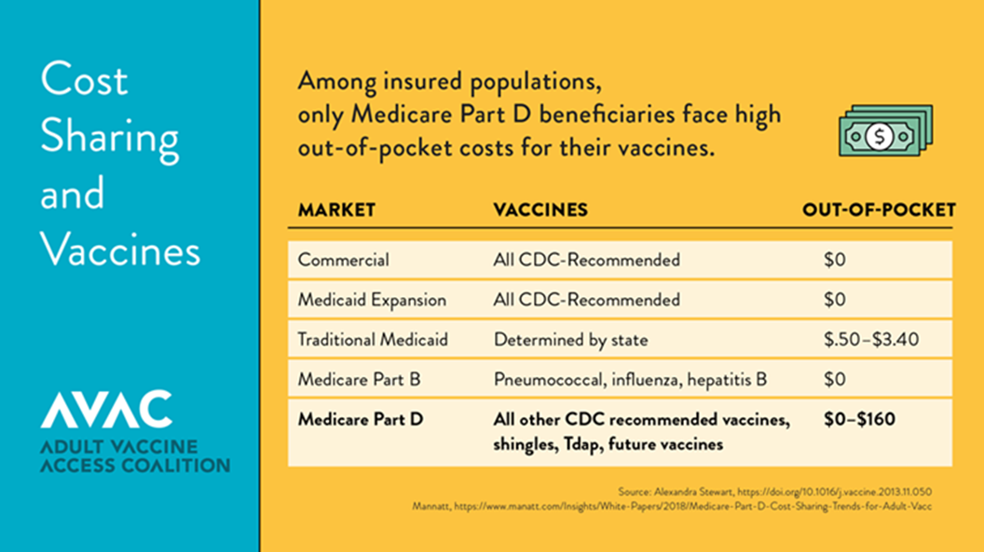

Organizations Supporting the Bill

Alliance for Aging Research
American Association of Occupational Health Nurses (AAOHN)
American College of Preventive Medicine (ACPM)
American Immunization Registry Association (AIRA)
American Pharmacists Association (APhA)
American Public Health Association (APHA)
Asian & Pacific Islander American Health Forum (APIAHF)
Association of Asian Pacific Community Health Organizations (AAPCHO)
Association of Immunization Managers (AIM)
Association for Professionals in Infection Control and Epidemiology (APIC)
Biotechnology Innovation Organization (BIO)
Dynavax
Families Fighting Flu
GSK
Hep B United
Hepatitis B Foundation
Immunization Action Coalition (IAC)
Infectious Diseases Society of America (IDSA)
Medicago
Merck
National Association of Chain Drug Stores (NACDS)
National Association of County and City Health Officials (NACCHO)
National Association of Nutrition and Aging Services Programs (NANASP)
National Consumers League
National Council of Asian Pacific Islander Physicians (NCAPIP)
National Foundation for Infectious Diseases (NFID)
National Hispanic Medical Association (NHMA)
National Viral Hepatitis Roundtable (NVHR)
Novavax
Pfizer
Sanofi
Scientific Technologies Corporation (STC)
Takeda
The Gerontological Society of America (GSA)
Trust for America's Health
Vaccinate Your Family

